- Find and list the IDs and spouse names of all employees who are married.
SELECT e_id, s_name
FROM employee_per
WHERE m_status = 'Y';
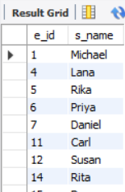
- Change the above so the display is sorted by spouse names.
SELECT e_id, s_name
FROM employee_per
WHERE m_status = 'Y'
ORDER BY s_name;
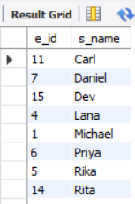
- How many employees do we have under each sex (male and female)?
SELECT sex, COUNT(*) AS number_of_employees
FROM employee_per
GROUP BY sex;
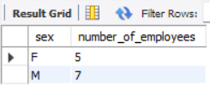
- How many of our employees are married and unmarried?
SELECT m_status, COUNT(*) AS total
FROM employee_per
GROUP BY m_status;
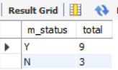
- Find the total number of children.
SELECT SUM(children) AS total_children
FROM employee_per
WHERE children IS NOT NULL;
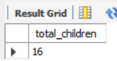
6. Make unique groups of children and find the number in each group. Sort with the group having the maximum children at the top.
SELECT children, COUNT(*) AS count_in_group
FROM employee_per
WHERE children IS NOT NULL
GROUP BY children
ORDER BY children DESC;
